Sunday, July 11th, 2021
7th Sunday after Pentecost
Holy Communion
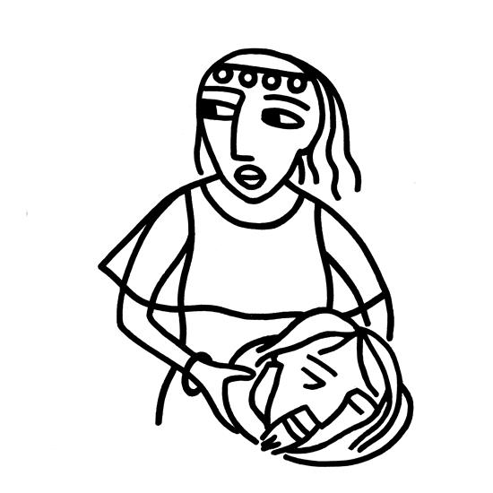

Grace Lutheran Church
301 E. Conan St., Ely, MN 55731
Church Phone: 218-365-5605
Email: gracelutheranelymn@gmail.com
Website: www.graceinely.org
Facebook: @gracelutheranely

Grace Lutheran Staff:

Pastor: Eric Thiele

Office Manager: Brian Naykki

Choir Director: Sarah Mason

Organists: Barb Litchfield & Karin Schmidt

Nursery Professional: Brian Naykki

Custodian: Dave Klaesges
* Please stand as your body allows.

+GATHERING+
Welcome and Announcements

Confession and Forgiveness P. 94-96
Almighty God, to whom all hearts are open, all desires known, and from whom no secrets are hid: cleanse the thoughts of our hearts by the inspiration of your Holy Spirit, that we may perfectly love you and worthily magnify your holy name, through Jesus Christ our Lord. Amen.

Let us confess our sin in the presence of God and of one another.
Silence is kept for reflection.

Most merciful God, we confess that we are captive to sin and cannot free ourselves.
We have sinned against you in thought, word, and deed, by what we have done and by
what we have left undone. We have not loved you with our whole heart; we have not loved our neighbors as ourselves. For the sake of your Son, Jesus Christ, have mercy on us. Forgive us, renew us, and lead us, so that we may delight in your will and walk in your ways, to the glory of your holy name. Amen.

In the mercy of almighty God, Jesus Christ was given to die for us, and for his sake God forgives us all our sins. As a called and ordained minister of the church of Christ, and by his authority, I therefore declare to you the entire forgiveness of all your sins, in the name of the Father, and of the + Son, and of the Holy Spirit. Amen.

*Gathering Hymn Christ, Whose Glory Fills the Skies #553

*Greeting
Leader: The grace of our Lord Jesus Christ, the love of God,
and the communion of the Holy Spirit be with you all.
People: And also with you.

*Prayer of the Day
Let us pray. O God, from you come all holy desires, all good counsels, and all just works. Give to us, your servants, that peace which the world cannot give, that our hearts may be set to obey your commandments; and also that we, being defended from the fear of our enemies, may live in peace and quietness, through Jesus Christ, our Savior and Lord. Amen.

+WORD+

First Reading……………………………. Amos 7:7-15
7This is what [the Lord God] showed me: the Lord was standing beside a wall built with a plumb line, with a plumb line in his hand. 8And the Lord said to me, “Amos, what do you see?” And I said, “A plumb line.” Then the Lord said, “See, I am setting a plumb line in the midst of my people Israel; I will never again pass them by; 9the high places of Isaac shall be made desolate, and the sanctuaries of Israel shall be laid waste, and I will rise against the house of Jeroboam with the sword.”
10Then Amaziah, the priest of Bethel, sent to King Jeroboam of Israel, saying, “Amos has conspired against you in the very center of the house of Israel; the land is not able to bear all his words. 11For thus Amos has said, ‘Jeroboam shall die by the sword, and Israel must go into exile
away from his land.’ ” 12And Amaziah said to Amos, “O seer, go, flee away to the land of Judah, earn your bread there, and prophesy there; 13but never again prophesy at Bethel, for it is the king’s sanctuary, and it is a temple of the kingdom.” 14Then Amos answered Amaziah, “I am no prophet, nor a prophet’s son; but I am a herdsman, and a dresser of sycamore trees, 15and the Lord took me from following the flock, and the Lord said to me, ‘Go, prophesy to my people Israel.’
”This is the Word of the Lord, Thanks be to God.

*Gospel Acclamation P.142…. Alleluia. May the God of our Lord Jesus Christ enlighten the eyes of our hearts,* that we may know the hope to which God has called us. Alleluia.

Gospel Reading………………………………….. Mark 6:14-29
The Holy Gospel, according to Mark, the third chapter. Glory to you, O Lord.
14King Herod heard of [the disciples’ preaching,] for Jesus’ name had become known. Some were saying, “John the baptizer has been raised from the dead; and for this reason these powers are at work in him.” 15But others said, “It is Elijah.” And others said, “It is a prophet, like one of the prophets of old.” 16But when Herod heard of it, he said, “John, whom I beheaded, has been raised.”
17For Herod himself had sent men who arrested John, bound him, and put him in prison on account of Herodias, his brother Philip’s wife, because Herod had married her. 18For John had been telling Herod, “It is not lawful for you to have your brother’s wife.” 19And Herodias had a grudge against him, and wanted to kill him. But she could not, 20for Herod feared John, knowing that he was a righteous and holy man, and he protected him. When he heard him, he was greatly perplexed; and yet he liked to listen to him. 21But an opportunity came when Herod on his birthday gave a banquet for his courtiers and officers and for the leaders of Galilee. 22When his daughter Herodias came in and danced, she pleased Herod and his guests; and the king said to the girl, “Ask me for whatever you wish, and I will give it.” 23And he solemnly swore to her, “Whatever you ask me, I will give you, even half of my kingdom.” 24She went out and said to her mother, “What should I ask for?” She replied, “The head of John the baptizer.” 25Immediately she rushed back to the king and requested, “I want you to give me at once the head of John the Baptist on a platter.” 26The king was deeply grieved; yet out of regard for his oaths and for the guests, he did not want to refuse her. 27Immediately the king sent a soldier of the guard with orders to bring John’s head. He went and beheaded him in the prison, 28brought his head on a platter, and gave it to the girl. Then the girl gave it to her mother. 29When his disciples heard about it, they came and took his body, and laid it in a tomb.
This is the gospel of our Lord. Praise to you, O Christ.

Sermon

Hymn of the Day Listen, God is Calling #513

*Apostles’ Creed Page 105

*Prayers of Intercession
Lord, in your mercy. Hear our prayer.
At conclusion: Amen.

*Sharing of Peace For those worshipping in person, we will use hand waves, bowing, peace sign, and elbow bumps. Please remain in your seats. For those worshipping online, you are invited to Share the peace in the comment section with the use of an emoji like the peace sign or a dove, a symbol of peace and of the Holy Spirit or just say peace.

+MEAL+
Offering - We will not be passing offering plates. They are placed at the entrance to the sanctuary and the fellowship hall. You are encouraged to place your offering in the plates as you enter or exit the worship areas.

*Offering Prayer
*The Great Thanksgiving Page 107
*Words of Institution Page 108
*The Lord’s Prayer Page 112
Communion- You received a communion cup as you arrived. Please have that ready as we will receive communion together at the same time. You will remain in your seats to receive communion. For those at home, you are invited to have bread and wine or grape juice ready. You may serve one another as we receive communion

*Table Blessing & Prayer after Communion

+SENDING+
*Blessing
*Sending Hymn Let Justice Flow Like Streams #717

*Dismissal
Go in peace. The Spirit sends us forth to serve.
Thanks be to God.

ANNOUNCEMENTS
* Ericka Javis, Lyle Klein, Amy Kromer, Zac MacKenzie, Byron Moren, Doris Nelson, Brian Naykki, Vicki Hall, Dick Hall, Shannon Stehman, Beverly Wiermaa, Dick Campbell, Mary Lou Carlson, Diane Kromer, Ande Visser, Dave Nichols, Bob Jalonen, Dave Casey
*Those in the military and their families.Please let the church office know if you would like to be included or include someone on the prayer list.
.

COMMUNION AT GRACE
Grace Lutheran practices open communion where everyone, regardless of religious background or tradition, is welcome to come forward to receive communion. If you are worshipping with children, know that they are also welcome to receive communion. To indicate this please have them open their hands to receive the bread or fold their hands against their chest to receive a blessing.

***Masks must be worn during singing parts of Worship***

Grace Commemorative Brick Program: If you are interested in ordering a commemorative brick, there are order forms on the welcome table. The deadline to order is Sunday, August 29. If you have any questions, please contact Sue Flesvig 365-2253.

Coffee on the parsonage lawn: While we will not be able to have Sunday Morning Fellowship in the church, we are encouraging you to gather in small groups on the parsonage lawn after worship. Bring a chair, maybe a thermos of coffee, and a smile. (You could also make a quick stop at the Front Porch, Northern Grounds, Log Cabin Coffee, or a gas station

WHAT’S HAPPENING AT GRACE…..

Pastor Eric will be away on continuing education from July, 12th until July, 18th. If a Pastoral emergency arises please call Brian in the office.

Sun., July 18th Deacon Brenda Tibbetts and Pastor Sue Smith will lead worship.

Today’s Worship Leaders and “Amazing Grace” Participants:
Pastor: Eric Thiele
Organist: Barb Litchfield
Lector: Larry Mischke
Ushers: Tina Foster, Sarah Foster, John Imsland
Readings for Sunday, July 18th, 8th Sunday after Pentecost: Jeremiah 23:1-6, Psalm 23, Ephesians 2:11-22, Mark 6:30-34, 53-56

